draft: work in progress

[Basic Exercises experience]

functional specification

# Executive Summary

## Background

Alliance Francaise de Shanghai students are mostly university students or employees. They go to AF to learn French at their spare time.

* Each semester lasts 4 months, and cost 3000 rmb
* Students can enter into next level if he passes the exam at the end of semester. Exam is composed of 2 sections: written 笔试and oral 口试. Written exam has 3 sections: listening (听力), reading (阅读)，writing (写作)。Oral exam is performed as conversation.
* There are 10 levels for general courses.
* Class starts with 20 students at the beginning, and 2 months later only 8 students keep coming.

Students meet teachers during class time. For A1.1 class, the class happens once a week at Saturday afternoon for 5 hours. At the end of a semester, an exam will be hold to test students learning skill. From a survey, 7 of 8 students ask teacher to share exercise materials and historical exam thru Email. These materials are available from AF server Yunio (e.g. <https://s.yunio.com/V5Jpia>), which are shared at the beginning of semester. However students need to type specific URL manually in a browser to download and unzip materials. From teacher perspective, they have a need to understand the results after one course such as how well his students have acquired lessons taught. They are interested to know pain points of his students, thus they can provide timely explanation during class.

## Proposal

We will re-design exercises sharing experience between teachers and students to:

* Facilitate students access to exercises materials: # download compared to Yunio, #students perform exercises
* Increase students confidence to pass exam: participate # =>
* Increase students exam notes: =>

We will support Android phones at the moment.

We will develop a learning assistant app for AF teachers by breaking down into 4 components. We might cover Messaging in another spec. We will have one version to cover Teachers persona, and the other version to cover Students persona.

The Parrot app will be composed of below components. This spec is focused on Basic exercises scenarios.

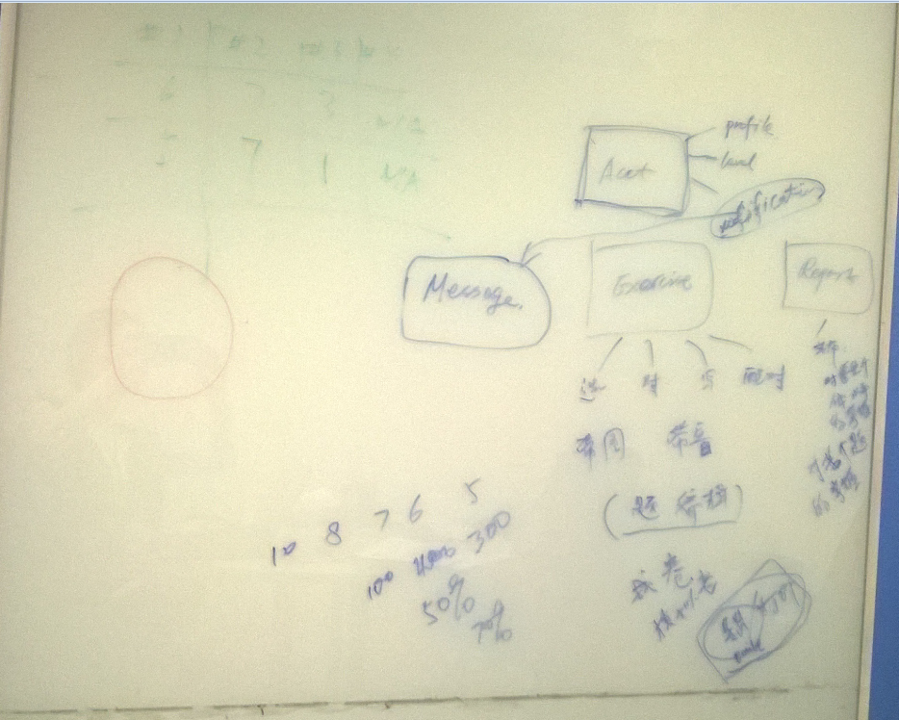

## High-level schedule

Each semester lasts for 19 weeks not including holiday. Our release will be based on AF semester schedule. M1 (milestone 1) refers to the semester September 22th 2014 – Feb. 1st 2015. M2 refers to the semester from Feb. – May 2015. M3 refers to the semester May – August 2015.

For M1 schedule

* Oct. 1st: self-host build ready for internal testing purpose.
* Oct. 1st – Oct. 15th: 1) self-hosting with internal participants. 2) Metric data auto-collection coding, 3) Feedback collection tool coding so that students/teachers can report issues directly from their phones.
* Oct. 31st : beta release with Feedback collection tool
* Nov. 1st – Feb. 1st: beta release for AF A1.1 students and teacher. (can we roll out App update whenever we wish to fix important bugs for example. )
* First week of January: survey with students and teacher.

How can we triage and track issues reported from students/teachers. Is there an existing 3rd party open source tool?

# Scenario Goals & Non-Goals

## Goals

## Following are goals for teacher persona. Definition of priority are: Pri1 must have, priority2 nice to have, and Priority 3 ok to cut.

## Teacher app will be replaced by Admin tool in M1. We will review this part in M2

|  |  |
| --- | --- |
| Goals for Teachers | Priority |
| Teacher can sign in with email account or phone # registered at AF, and set a password | 1 |
| Teacher can edit his profile info registered at AF | 2 |
| Teacher can create/rename/delete a group for exercises or historical exams.   * One group of exercise refers to a course level * One group of historical exams refers to an official exam at AF given a year/date | 1 |
| Teacher can bulk upload several exercises to a group from PC (or other approach such as 摄像功能，自动识别相片中的文字，然后手动编辑?) | 2 |
| Teacher can upload one exercise to a group from PC (or other approach such as 摄像功能，自动识别相片中的文字，然后手动编辑?) | 1 |
| Teacher can select exercises within a group to distribute to his students | 1 |
| Teacher can select groups of exercises to distribute to his students | 2 |
| Teacher can upload one historical exam | 1 |
| Teacher can bulk upload historical exams | 2 |
| Teacher can see statistic data about students participation | 1 |
| Teacher can see statistic data about exercise scores | 1 |
| Teacher can modify an exercise | 1 |
| Teacher can delete exercises from a group | 2 |
| Teacher can receive an offline message with a specific exercise attached from student | 2 |
| Teacher can reply back to one student as private message | 2 |
| Teacher can forward a message to another student | 2 |
| Teacher can forward a message to all students | 2 |
| Teacher can select if students can see correct answers after completing whole series or not | 2 |
| Teacher can receive a general message without attachment from student | 3 |
| Teacher can save his comment to a given exercise | 3 |
| Teacher can randomly generate pseudo-exams 模拟考卷 from existing historical exams | 2 |
| Teacher can recall back exercises distributed to students | 2 |
| Teacher can use scanner or camera to upload exercises (to be covered in Auto-upload spec) | 2 |

## Following are goals for student persona. Definition of priority are: Pri1 must have, priority2 nice to have, and Priority 3 ok to cut.

|  |  |
| --- | --- |
| Goals for Students | Priority |
| Student can sign in with his email account or phone # registered at AF, and set a password | 1 |
| Student can edit his profile info registered at AF | 2 |
| Student can select an exercise group or a historical exam to do | 1 |
| Student can see which exercises he has completed within a group (historical exercises) | 2 |
| Student can see which exercises he has not yet completed within a group | 1 |
| Student can see highlights on new exercises distributed from teacher | 1 |
| Student can get push notification at his mobile with new exercises | 2 |
| Student can answer exercises easily on the phone (with less gestures) | 1 |
| Student can answer exercises easily on Tablet (or the app will zoom on tablet) | 2 |
| Student can see his score after completing a group of exercises | 1 |
| Student can re-play exercises from beginning??? | 2 |
| Student can resume exercises | 1 |
| Student exercise status can roam to another device | 3 |
| Student can send questions related to an exercise to teacher thru message (to be covered in Messaging spec?) | 2 |
| Student can send a message to teacher (to be covered in Messaging spec?) | 3 |
| Student can export exercises (to PDF, Word, then to print these exercises out)   * Need to clarify in use of term that these exercises should not be used for business purpose | 3 |
| Student can see how long time he takes to complete a series of exercise | 3 |
| Student can save exercises to favorite | 3 |

## Non-Goals

|  |  |
| --- | --- |
| Non-Goals | Comment |
| Students non registered at the institute | We do not target public students, only students registered at AF. |
| Oral exercise (口语) | We will look into this scenario later. Need Audio/video |
| Written exercise (写作题) | We will look into this scenario later. |
| Distribute course record thru Video format | To be considered later, in another spec. |
| Messaging | To be covered in another Spec? |
| Real time 1:1 course between teacher and student | To be considered later, in another spec |
| Non-Android platform | To be considered later based on market share |
| Contacts | To be covered in Contacts spec |
| Advanced exercises (e.g. group assignment) | To be covered in another spec |

# Functional Requirements (High-Level) for Pri1 scenarios

## General requirements for App

|  |  |  |  |  |
| --- | --- | --- | --- | --- |
| App Setting | | | | |
|  | Font setting (font and font size) |  | 3 | Can be Pri2 for elder teachers. |
|  | UI language (Chinese/French/English)   * By default: be aligned with Phone languages |  | 1 | M1: provide default setting  M2: allow users to customize |
|  | Background picture |  | 3 |  |
|  | Term of usage |  | 2 |  |
|  | Help and Feedbacks collection |  | 1 | M1 |
| **Installation (on Android only)** | | | | |
|  | Install on mobile phone at first time   * Default install on the phone. * Data storage based on phone setting |  | 1 | M1: default setting  M2/M3: allow users to choose where to install: phone or SD card |
|  | Move the app to SD card |  | 2 | Probably fine not to cover in M1. |
|  | Uninstall with data removal |  | 1 | M1 |
|  | Uninstall by keeping data |  | 2 |  |
|  | Reinstall with data kept |  | 2 |  |

## Teachers Pri1 Scenarios

## Teacher app will be replaced by Admin tool in M1. We will review this part in M2

|  |  |  |  |  |
| --- | --- | --- | --- | --- |
| # | Requirement | Metrics | Priority | Milestone |
| **Sign-up/Sign-in/sign-out** | | | | |
|  | Sign-in with Email registered at the institute. | # sign-in attempts  # success/failure | 1 | M1 |
|  | Sign-in with mobile phone # registered at the institute | # sign-in attempts  # success/failure | 1 | M2: probably sign-up with Email is OK for M1? |
|  | User sign-out. | # sign-out attempts  #success/failure | 1 | M1 |
|  | User sign-up with Email and create a new password | # sign-up attempts  # success/failure | 1 | M1 |
|  | User sign-up with mobile phone # and create a new password |  | 2 | M2? |
|  | User change password | # pwd changed  # success/failure | 1 | M1 |
| **Manage one exercise or one historical exam to a group** | | | | |
|  | Upload/modify/delete a selective exercise (选择题) | # exercises  # success/failure | 1 | M1 |
|  | Upload/modify/delete a Yes/No or Yes/No/I do not know exercise (对错题). There are 2 types of 对错题   * Yes or No * Yes or No or I do not know (when it’s not mentioned in the text) | # exercises  #success/failure | 1 | M1 |
|  | Upload/modify/delete a written exercise (写作题) | # exercises  #success/failure | 2 | M2 |
|  | Upload/modify/delete a matching exercise (配对题) | # exercises  #success/failure | 1 | M1 |
|  | Upload/delete/modify an exercise with an audio file 听力题 (mp3, wav)  (what are audio format and size limit to support?) | # exercises  # success/failure  audio file size uploaded  Audio file format uploaded | 1 | M1 |
|  | Upload/delete/modify an exercise with several pictures (jpg, png, jpeg)  (what are image format and size limit to support?) | # exercices  # success/failure  # image files | 1 | M1 |
| **Manage Group** | | | | |
|  | Create a group and auto-assign with a default name   * One group for exercises refers to a course level * One historical exam group refers to a specific year/date for that exam | # groups created | 1 | M1 |
|  | Validate group name if not exist |  | 1 | M1 |
|  | Check group name with restriction upon creation? Do we need to apply some name convention here? |  | 2 |  |
|  | Delete a group (exercises in the group will be deleted too)  (how about a group distributed? Or only allow to delete if not distribute? If yes, teacher needs to recall the group first) | # groups deleted | 2 |  |
|  | Delete several groups (how about groups distributed?) |  | 2 |  |
|  | Rename a group after its creation  (how about if a group is distributed to students already? Or this is only allowed when a group is not distributed?) | # groups renamed | 1 | M1 |
| **Distribute exercises to students** | | | | |
|  | Tag a group for distributed or not distributed |  | 1 | M1 |
|  | Select and Distribute an exercise from a group |  | 1 | M2:  Assume at the beginning teacher will rather bulk distribute exercises instead of distributing one single exercise |
|  | Select and Distribute several exercises from a group |  | 1 | M1 |
|  | Select and Distribute one group |  | 1 | M1 |
|  | Select and Distribute several groups |  | 2 | M2/M3? |
| **Report – students/exercises/time** | | | | |
|  | Print out report |  | 3 |  |
|  | Teacher can see # of exercises completed by students given a time frame |  | 1 | M2 |
|  | Show summary report (with Pie format) |  | 1 | M1 |
|  | Select one section in Pie and break down into a detailed report |  | 1 | M1 |

## Students Pri1 scenarios

|  |  |  |  |  |
| --- | --- | --- | --- | --- |
| # | Requirement | Metrics | Priority | Milestone |
| **Sign-up/Sign-in/sign-out** | | | | |
|  | Sign-in with Email (not everyone provides email upon registration) | # sign-in attempts  # success/failure | 2 | M2 |
|  | Sign-in with mobile phone | # sign-in attempts  # success/failure | 1 | M1 |
|  | User sign-out | # attempts  #success/failure | 1 | M1 |
|  | User sign-up with email, license code and set a new password | # attempts  # success/failure | 2 | M2 |
|  | User sign-up with mobile phone # and create a new password |  | 1 | M1 |
|  | User change password | # attempts  # success/failure | 1 | M1 |
| **Conduct exercises and historical exams** | | | | |
|  | Answer a selective exercise (选择题) | # exercises  # success/failure | 1 | M1 |
|  | Answer a Yes/No exercise (对错题) | # exercises  #success/failure | 1 | M1 |
|  | Answer a written exercise (写作题) | # exercises  #success/failure | 2 | M3 |
|  | Answer a matching exercise (配对题) | # exercises  #success/failure | 2 | M2 |
|  | Upload audio file to an exercise听力题 (mp3, wav)  (what are audio format and size limit to support?) | # exercises  # success/failure  audio file size?  Audio file format? | 1 | M1 |
|  | Upload pictures to an exercise (jpg, png, jpeg)  (what are image format and size limit to support?) | # exercices  #success/failure  # image files | 1 | M1 |
| **Show exercise group and historical exams** | | | | |
|  | List of exercises and exams (what is default view: by course level) |  | 1 | M1 |
|  | View by sorting groups with date of publishing | # view selected | 2 | M3 |
|  | View by sorting groups with completion status | # view selected | 2 | M2 |
|  | View by sorting groups with course level followed with years of exams | # view selected | 1 | M1 |
|  | From group list view, each group shows # completed / # total |  | 1 | M1 |
|  | From one group view, show # completed, # correct, # wrong |  | 1 | M1 |
|  | From one group view, show list of exercise groups so students can jump to quickly??? |  | 2 | M3 |
|  | From one group view, show an arrow to enter into next exercise level |  | 1 | M1 |
|  | From one group view, show an arrow to enter into previous exercise level |  | 2 | M2 |
|  | From one group view, show an arrow to be back to group list overview. |  | 1 | M1 |
|  | Hide/Unhide a group |  | 2 | M3 |
|  | Delete a group (maybe needed due to storage size on local devices???) |  | 2 | M3 |
| **Notification experience** | | | | |
|  | Show new exercises # distributed on App icon |  | 1 | M1 |
|  | Show new exercises # distributed information at Notification center |  | 1 | M1 |
|  | Click notification message will launch the app |  | 1 | M1 |
|  | Turn on/turn off the notification   * Turn on by default |  | 2 | M1: turn on by default  M2: allow to turn off. |

# Detailed

## Students first experience with Parrot app

For a student to sign in the app, he will need an access code and a default password. Prior to this, teacher or admin will generate the code thru Admin tool. One code will be assigned to one class given one semester. At the end of the semester, the code will expire. For a new semester, teacher can require a new access code with the admin tool.

When a student signs up, he needs to provide his name which will be displayed at the app. Password needs to be changed too at first usage of the app too.

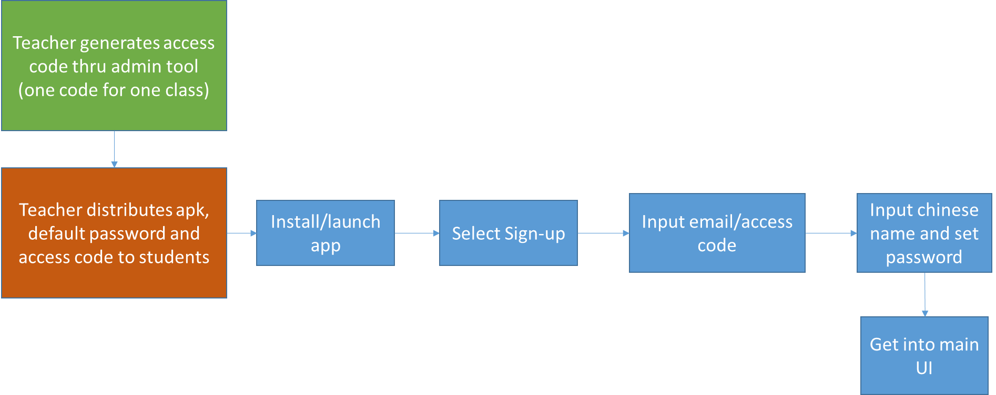

## Student second sign-in flow is as blow.

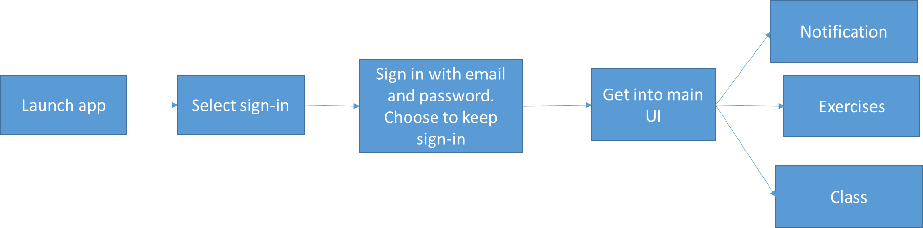

## Exercises general flow

Student can pause or exit the app and resume exercises. Student can restart doing exercises from the beginning and his score will be updated accordingly. Before final submission, students can move back to previous exercises to correct his answers. After students submit his answers, teacher will be able to view it from his side and generate statistic reports for his class in M1. In M2, we will design interaction between teachers and students for exercises thru the app.

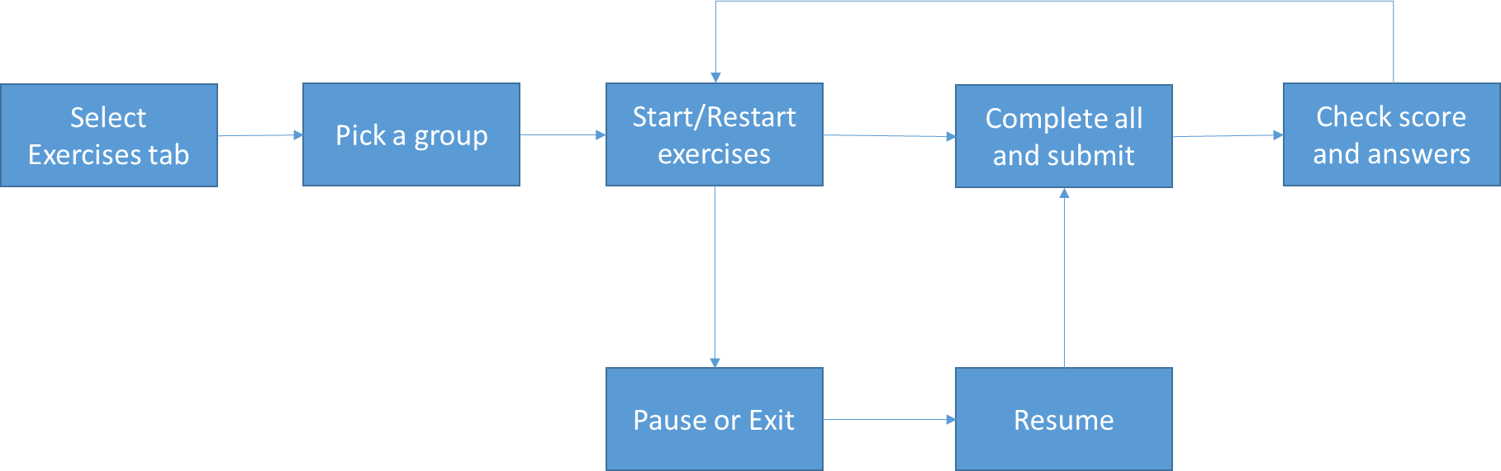

## Notification flow

Open issue: do we allow students to save messages as favorite (e.g. msg regarding exams). Do we allow students to delete msg ?

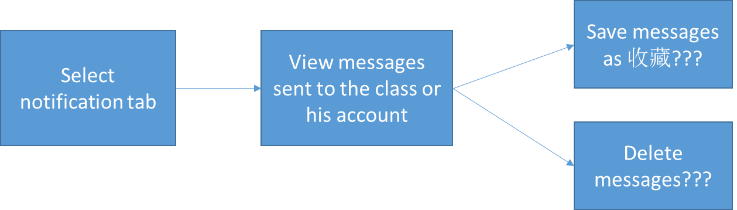

## Class flow

M1 students can only view teacher and list of students in a class.



# Success Measurements & Instrumentation

## General Success Metrics

NOTE: Most of these metrics should be seen **Exercises** goals while during M1 we potentially have two Apps in parallel which might skew some of the success metrics.

|  |  |  |  |  |  |
| --- | --- | --- | --- | --- | --- |
| Scenario: General Basic exercises metrics | | | | | |
| Question | **Usage Plan** | | **Pri** | **Metric (s)** | **Success metric (s)** |
| Measuring Launching  Do first time users install and open the app? | If we do not meet the installation metrics we need to improve the way we promote the app to the users for its benefits. | | 1 | * How many installation of the app? * How many times was the app opened per user? * From the first time the app was opened, how long did it take for a user to start doing exercises * The first time from when they open the app to the next time they open | Quantitative Success metric:   * Phone/tablet:   + during first week, **50%** users install and open at least once   + during first month, **80%** users install and open at least once * Average time from the first time from when they open the app to next time they open it is **less than a week**   Qualitative Success metric:   * **70%** of users think the app is helpful for their study. |
| Measuring Adoption  Do first time users start to perform exercises after they open the app?  How many students don’t perform exercises at first experience? | We expect students to start performing exercises at first time when launching the Parrot app.  If we do not see the usage pattern to be leaning towards 1st experience we'll rethink the experience or content delivered | | 1 | * #/% of users start exercises at 1st launching * #/% of users start exercises after 1st launching (Do users continue to do exercises after 1st experience?) * #/% of exercises completed per user * #/% users completed per exercise (Is exercise format easy for students to understand and execute?) | Quantitative Success metric:   * **80%** users start exercises after opening the app * **50%** users complete all exercises after one month? * Overall # exercises completed **increased** over time |
| Measuring Reliability  Do our users successfully complete/submit exercises without error or crash? | We expect users to feel empowered to do bunch of exercises through the end without hitting error. If user gets error or the app crash more often, we need to revisit why that is. If people do not successfully submit, we need to revisit robustness. | | 1 | * % of Successful exercises by returning OK * % of exercises encountered error or app crash when submitting or inputting. (any constraint on Phone device, e.g. memory limit?) | Quantitative Success metric:   * **90%** success rate when doing exercises without error/crash |
| Measuring Performance  Do users feel answering exercises from the app is fast and fluid? | We expect users to feel fluid when conducting exercises one by one. If people take more time to submit or pass to next exercise, we will revisit the experience | | 1 | * Average time taken to complete an exercise per type | Qualitative Success metric:   * we get +4 (out of 5) on the perceived perf rate assessed via user feedback   Quantitative Success metric:   * Avg. time taken to submit an exercise is < than X seconds (Need to look at 智商小测试data shared at Wechat for example to come up with a number here) * Time taken to complete/submit an exercise is equal to or lesser than 小测试 at Wechat (?) |
| Measuring Usability  Do users like the experience of conducting exercises using our app? | | Tweak the design for the share workflow and get more user feedback from flighting and A/B testing. Iterate this process till we achieve our success metrics | 1 | # of users follow the designed flow to complete exercises (to submit, to pass to next, to exit, etc.)  # of exercises not done by a user | Qualitative Success metric:  For the exercises feature, we get +4 (out of 5) positive appeal rate assessed via user feedback  80% users find the design is intuitive via user feedback.  Quantitative Success metric:   * <20 % exercises are not done by the user. |

# Telemetry & Test in Production

[Guidelines](https://microsoft.sharepoint.com/teams/osg_threshold_specs/SitePages/Telemetry.aspx)

## Telemetry

## Test in Production

# Risks & Open Issues

[Guidelines](http://portals/wpblue/blue/teams/rm/Pages/Risks_OpenIssues.aspx)

## Risks

## Open Issues

# DOCUMENT UPDATE HISTORY

|  |  |  |
| --- | --- | --- |
| Date | Author | Changes |
| 8/15/2014 | Fei Wu | First Draft of one pager |
| 8/30/2014 | Fei Wu | Initial Review of scenarios, goals and non-goals complete |
| 9/22/2014 | Fei Wu | High level requirement review complete |
| 9/10/2014 | Fei Wu | Add general metrics |

appendix

# Definitions & Acronyms

# References

# Feature Q&A / Decisions

# Appendix (Deleted content that may be of use later)